HOW TO FIND YOUR CITYMAIL USERNAME FOR WeBWorK
CCNY Student Quick Guide

Why you need this
To access WeBWorK you need to know your what is your Citymail username and password. If you do not remember it, the CCNY Password Reset page can display your Citymail User Name and change your password.
STEP 1 Open the CCNY Password Reset page
Go to: https://reset.ccny.cuny.edu/  You can also scan the QR code to open the official CCNY password reset page. | 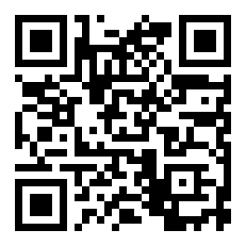
STEP 2 Select Student Password Reset
On the Password Reset page, click the Student Password Reset button.
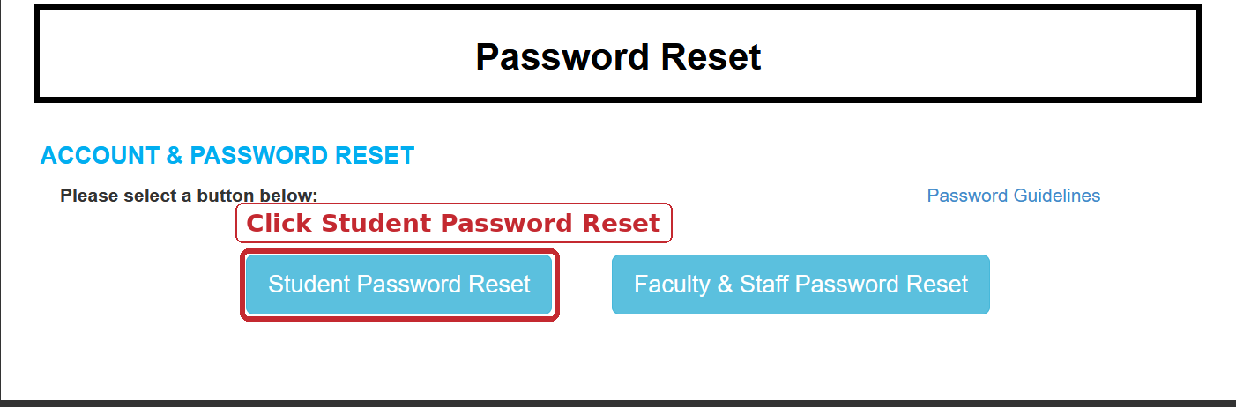
STEP 3 Enter your information
Enter your last name, the last 4 digits of your SSN, and your date of birth, then continue to the confirmation screen.
Privacy reminder
Enter this information only on the official CCNY Password Reset page. Do not email or send your SSN or date of birth to your instructor.

Finding the username on the confirmation screen
STEP 4 Locate User Name
At Step 2, the confirmation screen displays your Citymail User Name and Citymail email address. This appears before the page asks you to create a new password.
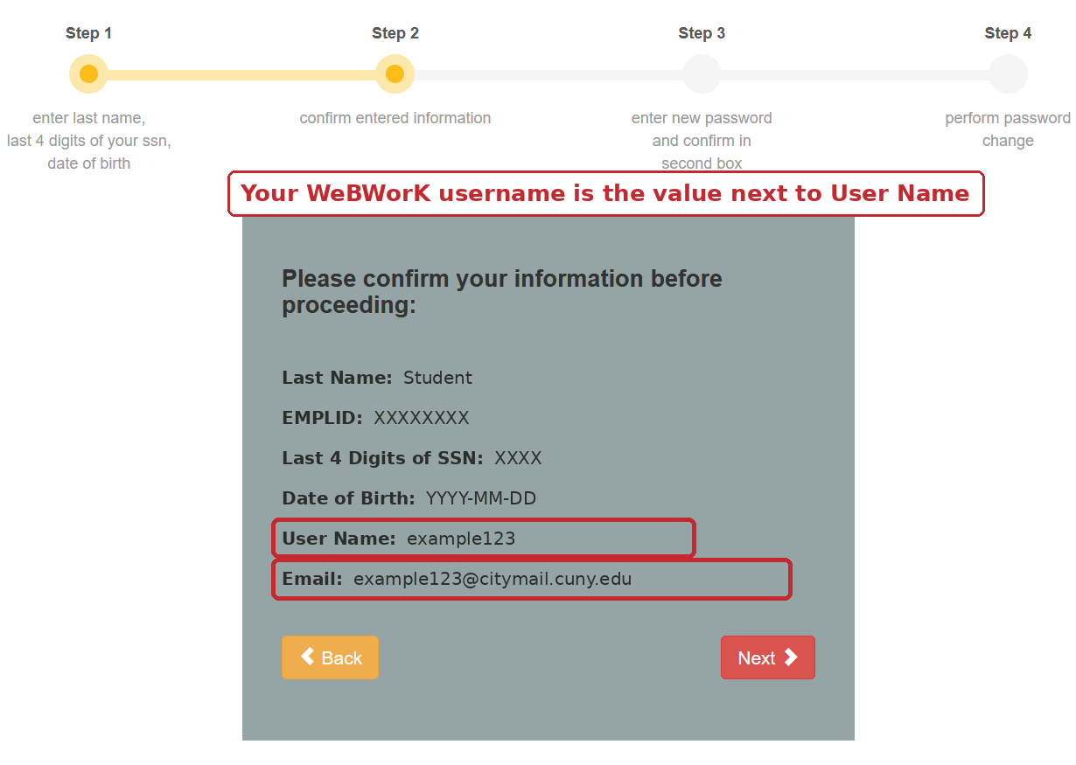
Use the User Name for WeBWorK
Example: User Name: example123 means your WeBWorK username is example123. Do not enter the full Citymail email address unless your course specifically tells you to do so.
STEP 5 Stop here if you only needed the username
You have not changed your password yet. If you only needed the username, you can close the page. If you also forgot your password, click Next and complete the password reset.
STEP 6 Log in to WeBWorK
In WeBWorK, enter the Citymail User Name in the Username field - not the full email address. Then enter your CCNY/Citymail password, or the new password if you completed the reset.
If you have trouble
Your current CCNY student email may be different from your older Citymail address. If the User Name does not appear or the WeBWorK login still fails, contact your instructor, send them your Citymail username. They may have to add you to the Webwork course.

