**Spring 2014 Makeup Final**

1)a) Consider the following argument. Draw a carefully labeled diagram for each one to test the validity of each argument. State whether the argument is valid or invalid. (6 pt.)

Premise: All pro athletes go to training camp.  
Premise: Bruce Wayne doesn't go to training camp.  
Conclusion: Bruce Wayne is not a pro athlete.  
  
b) For the following exam scores, find the mean, median and the five-number summary and make a box plot. (5 pt.)

94, 86, 78, 85, 76, 70, 65, 51, 85, 86, 99, 67, 74, 86, 99, 94.

2) a) A Boeing 747's fuel efficiency is approximately 0.2 miles per gallon. A Prius plug-in hybrid's fuel efficiency is approximately 50 miles per gallon. The distance from New York City to Miami is 1,091 miles. If the Boeing 747 carries 568 people and the Prius carries 2 people from New York City to Miami, calculate the gallons of fuel burned per person for each vehicle. (7 pt.)

b) If the bus fare in a certain city rose from $1.75 to $2.00, what percent increase would that be? (4 pt.)

3) a) Suppose you purchase a bag of coffee beans with a retail price of $11.99. The local sales tax rate is 8.875%. What is the final cost? Round to the nearest cent. (6 pt.)

b) If the value of a pension fund rose 20% one year, and fell 8% the next, what was the net percentage increase over the 2-year period? (5 pt.)

4) A waiter earns $400 per month (pre-tax) from an hourly wage and the rest of his pay is from tips. On average, he gets 20% of what a customer is charged in tips.

a) Find a function that gives his total pay in a month as it varies with the total amount his customers are charged in that month. (5pt.)  
b) If his customers are charged a total of $5,500 in a month, what is his total (pre-tax) pay for that month? (3 pt.)  
c) If he wants to make $1,700 per month (pre-tax), how much does he need his customers to be charged per month? (3 pt.)

5) a) In a recent survey people were asked if the took a vacation in the summer,

winter, or spring in the past year. The results are summarized in the following Venn diagram.

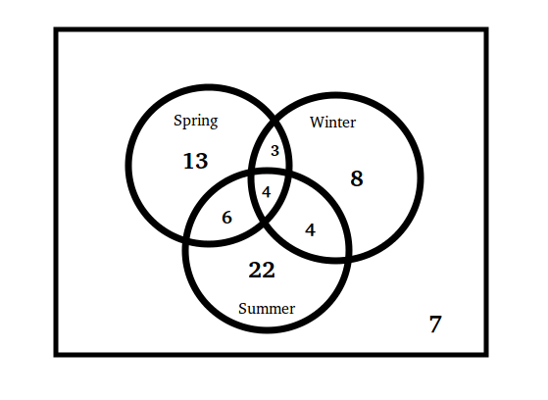

How many people took a vacation in only in the Summer?

How many people took more than one vacation?

How many people did not take a vacation during the Winter?

(6 pt.)

b) Draw a carefully labelled Venn diagram to represent the following data and answer to the following question:

In a survey of 70 first-year students, 30 were enrolled in a math course and 50 were enrolled in a writing course. Of those enrolled in the writing course, 21 weren't enrolled in a math course. How many students in the survey were enrolled in neither a math course nor a writing course? (5 pt.)

6) a) The Consumer Price Index for the year 1970 was 38.8 and for the year 2012 was 229.6. If someone needed a $30,000 annual salary to maintain a certain standard of living in 1970, how much would be needed to maintain the same standard of living in 2012? (4 pt.)

b) In October 2013, the national debt reached 17,075 billion dollars. Rewrite that amount in scientific notation. (4 pt.)

c) A person earns 6 times as much now as in the person’s previous job.

That’s like getting a ____% raise. (3 pt.)

7) a) Identify at least one potential source of bias in each of the following studies. Explain your answers clearly.

To determine what percentage of New Englanders are Republicans, a political science researcher polls students at the University of Vermont. (5 pt.)

b) The pass rate in one math course went from 60% last year to 70% this year. What was the relative change in pass rates? (6 pt.)

8) a) Peru's population is about 30.4 million and its yearly growth rate was approximately 1.25%. If the growth rate stays constant, what will Peru's population be in 2100? (6 pt.)

b) Rubidium-82 has a half-life of 75 seconds. How much of a 5000 gram sample remains after 10 minutes? (5 pt.)

9) If gas costs $3.40 per gallon, and your car averages 30 miles per gallon,

a) How far can you go on $150 worth of gas? (5 pt.)

b) How much would it cost you to drive 3,000 miles to California? (6 pt.)

10) a) How much would it cost to carpet an 6 foot by 11 foot room with carpeting that costs $25 per square yard? Round your answer to the nearest dollar. (6 pt.)

b) An amoeba cell is about 2.5 x 10-4 meters in length. If you were to line up 7 billion amoeba,

end-to-end, what is the total length? You must convert all numbers to scientific notation, calculate the

length and leave the final answer in scientific notation,correct to two decimal places. (5 pt.)

11) Consider the chart below depicting automobile sales (in millions) in the US for several years. Show the figures and calculations you’re using to answer each question.

a) In 1977, domestic sales represented what percent of total sales? (5 pt.)

b) Comparing 1973 and 1983, in which year did imports represent a greater percent of total sales?

In which two-year period did total sales decrease the most? By what percent? (6 pt.)  
  


12) A sample of gas stations around Manhattan suggests that the price of a gallon of gasoline is normally distributed with a mean of $3.74 and a standard deviation of $0.17. Assume the sample is representative to answer the following questions.

a) What percent of gas stations price gasoline at more than $3.70 per gallon?  
b) What percent of gas stations price gasoline between $3.70 and $3.85 per gallon?  
c) Among 30 gas stations in Manhattan, how many would you expect to be cheaper than $3.60 per gallon?