Math 150 Final Exam Fall 2011
City College of New York

Answer 9 complete questions. Omit three complete questions. Calculators are permitted on the exam.
If not otherwise specified, give all measurements to two decimal places. Show your work. Each question is worth 11 points with 1 free point.

1. a) Write the negations of the following statements:
i) Some dogs do not eat vegetables. ii) No people who go to a gym are overweight.
b) For the following argument draw a carefully labeled Venn diagram and using it, state whether the argument is valid or invalid.
Premises: All cowboys eat meat. No cowboys are tall.
Conclusion: No people who eat meat are tall.

2. a) It costs $17 per square foot to buy and install a certain kind of tile on a floor. Find the cost of buying and installing that tile in a large rectangular room that measures 8.5 yards by 15 yards. (3 feet = 1 yard)
b) If 1 kilogram = 2.2 pounds, how many pounds in 550 grams?

3. a) In 2009 the weight of a large Godfather pizza was 19.5 ounces. In 2010, the weight rose by 26%. In 2011 the weight fell by 35% from the last weight in 2010. Find the weight of the large Godfather pizza in 2011. Show your calculations.
b) Change 0.0276 kilometers to centimeters.
4. a) Using the rule of 70, find the doubling time of a wolverine population that grows by 1.4% each month. Include units in your answer.
b) The top speed of a cheetah is 70 miles per hour. Find its top speed in feet per second correct to two decimal places. Use the fact that 5280 feet = 1mile.

5. A small publishing company will publish a book for a fixed $650 initial setup charge and an additional charge of $7 per book. They cannot print more than 500 copies of the book.
a) Write an appropriate equation that expresses the entire cost C as a function of n, the number of copies of the book printed.
b) Find the domain and range of the function.
c) Find the entire cost of printing 100 copies.
d) Find the number of copies that can be printed for an entire cost of $2295.
6. a) Parents buy a bond whose value is $2500 for their new born son. The value of the bond increases by 6% at the end of every year. Find the value of the bond after 21 years.
b) At a company, 67 of the employees are women. 55 of the women have college degrees. 43 of the men have college degrees. If the company employs 125 people, how many of the men do not have college degrees? Show your work by drawing a Venn diagram. (Hint: Use only one circle for the sex of the people at the company.)

7. a) Light travels approximately 6 trillion miles in a year, so a distance of 6 trillion miles is called a light year. A star is 1.57 million light years from earth. Write both of this numbers in scientific notation and calculate the distance in miles from the star to the earth. Leave your answer in scientific notation.
b) The half-life of a radioactive is 15 days. Find how much of a 4000 gram sample remains after 90 days.

8. a) A study is to be conducted to determine whether large doses of vitamin C can decrease the severity of a cold by comparing 2 groups, one of which will be given large doses of the vitamin and the other will not.
i) Explain the placebo effect for this study. ii) How could they make the study double-blind?
b) A dress costs $ 162.74 after 8.5% sales tax. Find the cost of the dress before tax.

9. Scores on a civil service exam are normally distributed with a mean of 160 points and a standard deviation of 25 points. Use the chart on the last page of the exam for this question.
a) Find the percentage of scores that falls below 140 points,
b) Find the percentage of scores that falls between 130 and 170 points.
c) A person who receives a grade of at least 195 will be offered a job. If 1280 people take the test, how many would be offered a job?
10. The heights of 14 students are (in inches): 63, 63, 63, 64, 65, 65, 66, 68, 68, 68, 69, 70, 71, 75.
a) Find the mean, median, mode and range correct to one decimal place.
b) Copy the scale below. Give the 5-number summary and use the scale to draw a box plot. Explain the meaning (for the data set) of the last two numbers in your 5-number summary.

|------|------|------|------|------|------|------|------|
60 62 64 66 68 70 72 74 76

11. a) Using 1983 as the base year (100), the CPI for 1975 is 53.8 and for 1991 is 136.2. Suppose a weekly basket of food for a family of four cost $ 79 in 1975, find the cost of an equivalent basket in 1991.
b) If the CPI in 1981 is 90.9 and in 1982 is 96.5, find the rate of inflation from 1981 to 1982
c) If a Euro is worth $1.38, what is $1.00 worth in Euros?

12. Consider the following graph, showing the unemployment rate in the U.S. at the start of each decade. The graph shows the percent of people unemployed out of the total labor force. For credit, you must show the numbers that you use for your calculations in each part of the problem.

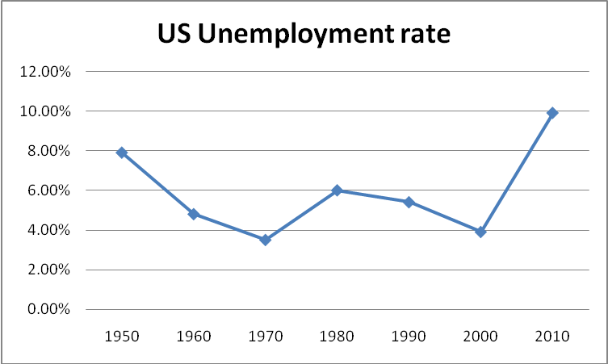

- Find the change in percentage points (absolute change) in the unemployment rate between 1950 and 1970.
- If there were 135, 200,000 adults in the labor force in the year 1990, how many were unemployed?
- Find the relative change in the unemployment rate from the year 2000 to the year 2010.

END
Good Luck!
Standard scores and percentiles for normal distributions

